Challenge 1: Testing your knowledge

This document contains ways of introducing learners to Power BI. This task uses data from tv shows and movies available on Netflix.

Download the file “Netflix_titles.csv”.

Below there is the set of tasks that you need to complete.
Try to complete this by yourself using the labs and lesson resources covered in the past weeks.
The solution will be made available to you on Blackboard at the end of the week. Good luck!

- Import the data. This is a .csv file NOT an Excel file. Do you remember how to load it?
Open the Power Query editor (by clicking on Transform Data) to perform the following data pre-processing steps:
- Remove the empty rows in the “director” column (how would you do that?)
- Remove all the empty rows in the “cast” column (how would you do that?)
- Create a new table “Type” – this table must contain only the “show_id” column and the “Type” column. Watch this short video if you’re not sure how to do this step: link to video
- Remove the “type” column from the Netflix_titles table
- Close and apply your changes, go to Data view and check that you have two tables with one relationship as shown below. If not, you have to create the relationship manually.
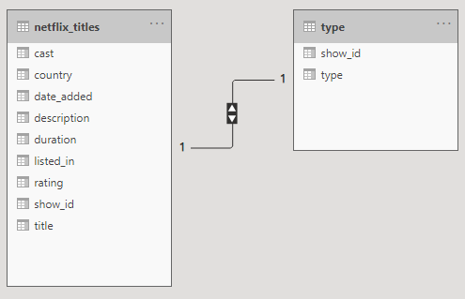
If the double arrow is not showing in your model, don’t worry. You are probably using a different version of Power BI. What matters is that you have a 1-to-1 relationship (1s on both sides).
- Then create another table called “Date”, containing only the show_id and date_added columns.
- Remove the date_added column from the Netflix_titles table.
- Close&Apply your changes, you should now have the three tables below:

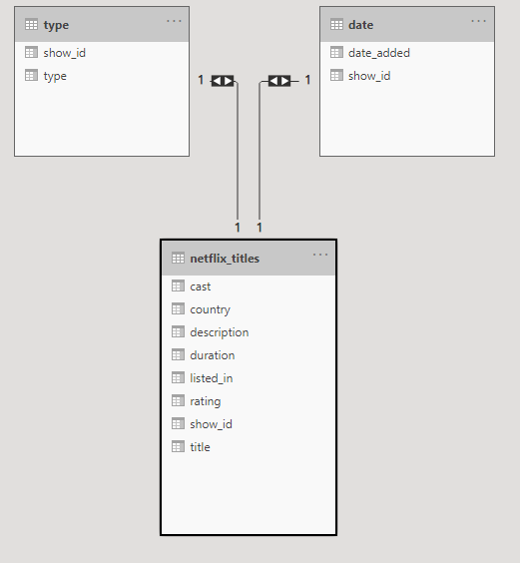
If the double arrows are not showing in your model, don’t worry. You are probably using a different version of Power BI. What matters is that you have a 1-to-1 relationship (1s on both sides).

The 4 steps below will require a bit more investigation in Power Query Editor. Click on Transform Data and Explore all the tools available to complete these steps.

- Then, remove all the “TV Show” types from the dataset by filtering out (removing) all the rows in the “type” table containing “TV Shows”.
- In the “Netflix_titles” table, look for the “duration” column and remove all the rows that contain the word “Season”, e.g. “1-Season”, “2-Seasons” etc...
- Remove the word “min” from each row of the “duration” column. You should leave only the numbers in each row.
- Change the data type of “duration” into whole number

The next part of this task will focus on your reporting skills. You will have to explore the different Power BI reporting tools to be able to complete these tasks.
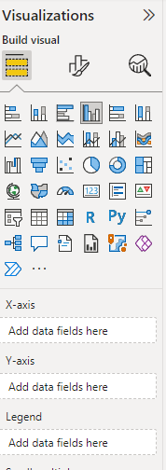
Remember that you can select the chart and use the Format and
Analytics tab to change any formatting options.

- Create the map below that shows the variance of duration by country

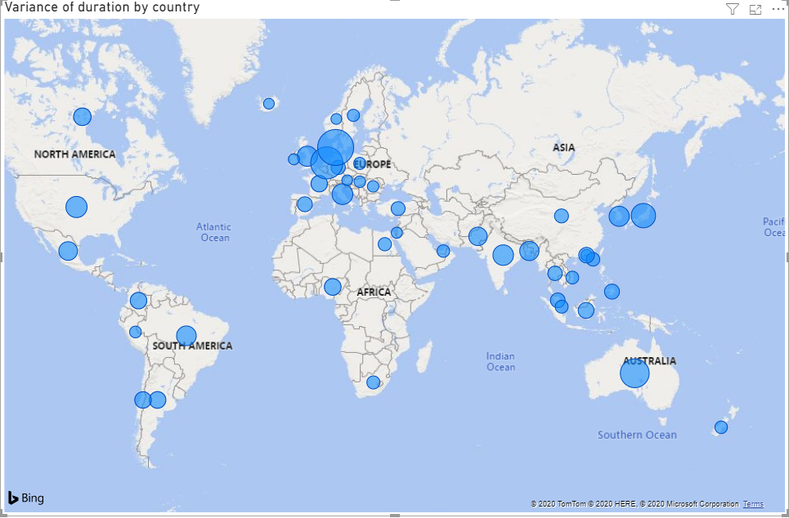

Explore the format tab to complete the tasks below 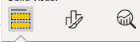

- Change the title text-size to 16.
- Centre the title
- Change the colours of the blue bubbles into red
- Filter all values of “Variance of duration” to show items greater than 60. Hint: use the Filters panel

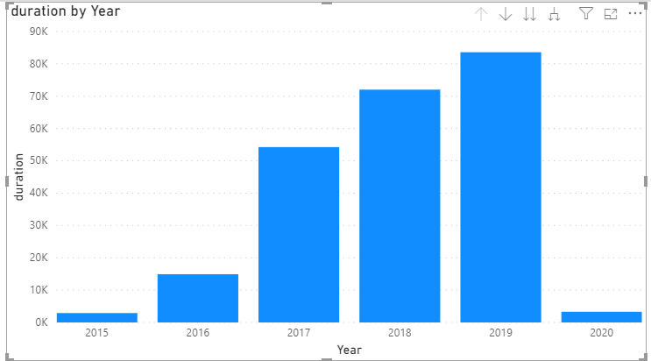
- On a new page of your repot, create the chart on the right that shows the duration by year.
- Change the colour of the bars into red
- Remove the title of your chart.
- Change the name of the y-axis into “Duration in minutes”.
- Explore and use the Analytics tab to add the “Average Line”.

- Label the average line “Average duration in minutes”.
- Show both the label of the line and the value
- Change the colour of the labels into black
- Change the colour of the average line into black.

The final chart should look like the one below:

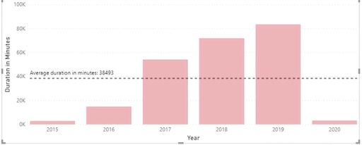
Once you have completed this task, you can complete the Data analytics task on Blackboard where you will be using new charts to address some business questions.

